Blnk technical interview task

In this document we will demonstrate how does the system work and we will discuss the assumptions for the business cycle:

First: the loan providers add some fund to the bank which is gonna be used later to give loans to customers

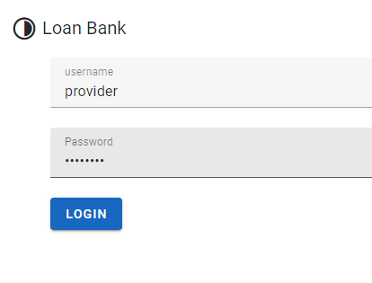

When the provider logs in with his credentials, he gets redirected to the provider view

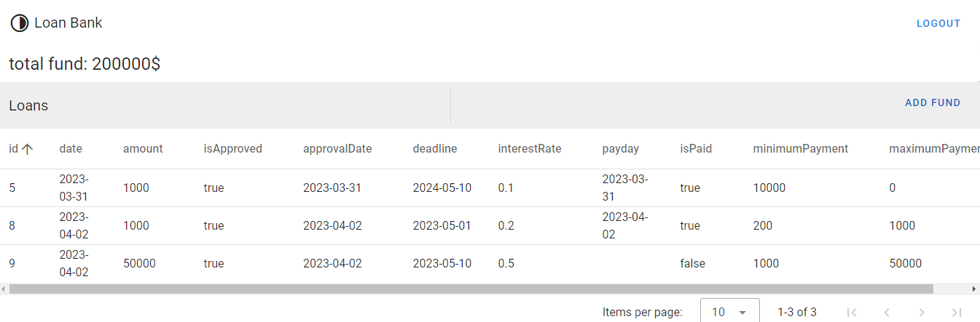

In the provider view he can check the total fund he added to the bank, check all the loans that were taken from his fund, and add more fund to the bank.

If the provider needs to add more fund to the bank he can click on ADD FUND button and it will show them a dialog with the required amount of fund to add to the bank

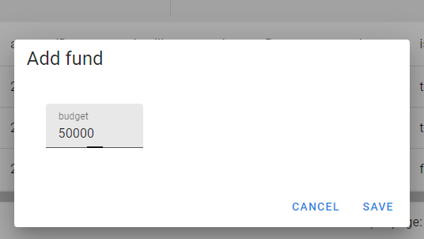

After the loan provider saves the required budget to be added, it will be submitted to the backend and it will show up on the total fund field at the top left corner

